Ideation Phase
Define the Problem Statements

Date | 16 June 2025
Team ID | LTVIP2025TMID53112
Project Name | OrderOnTheGo
Maximum Marks | 2 Marks

Customer Problem Statement Template:
To define the core problems faced by users and restaurant owners in local food ordering scenarios, and use those insights to guide the development of OrderOnTheGo.
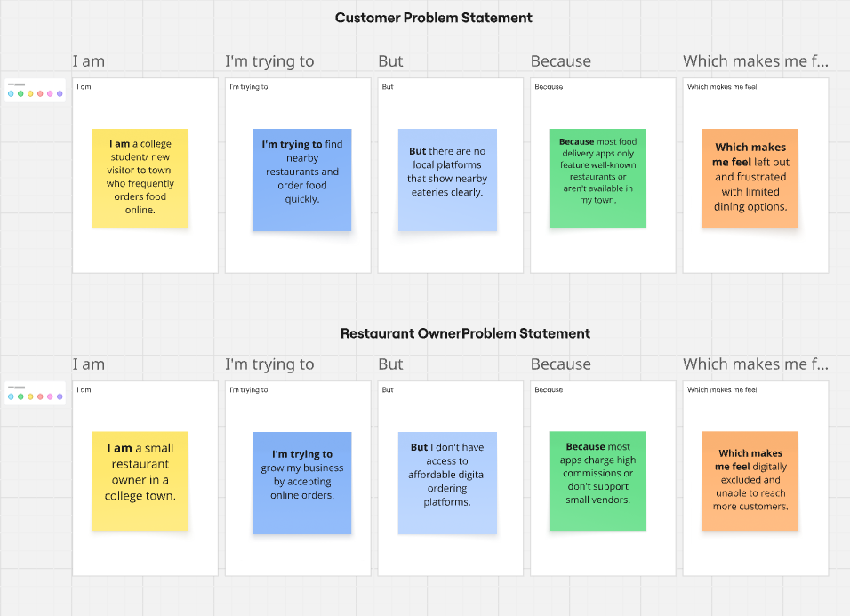
Link : https://miro.com/app/board/uXjVIj4I_7c=/?share_link_id=867770432634
Reference: https://miro.com/templates/customer-problem-statement/

Problem Statement (PS) | I am (Customer) | I’m trying to | But | Because | Which makes me feel
PS-1 | I am a college student/ new visitor to town who frequently orders food online. | find nearby restaurants with good food | there is no dedicated platform for local options | big food delivery apps don’t support smaller towns/restaurants | left out, with limited choices
PS-2 | a restaurant owner in a local area | reach more customers and manage online orders | I don’t have access to any digital ordering system | most platforms are expensive or don’t onboard small vendors | helpless and digitally excluded

